**Dauer Rotary Tree Saw**

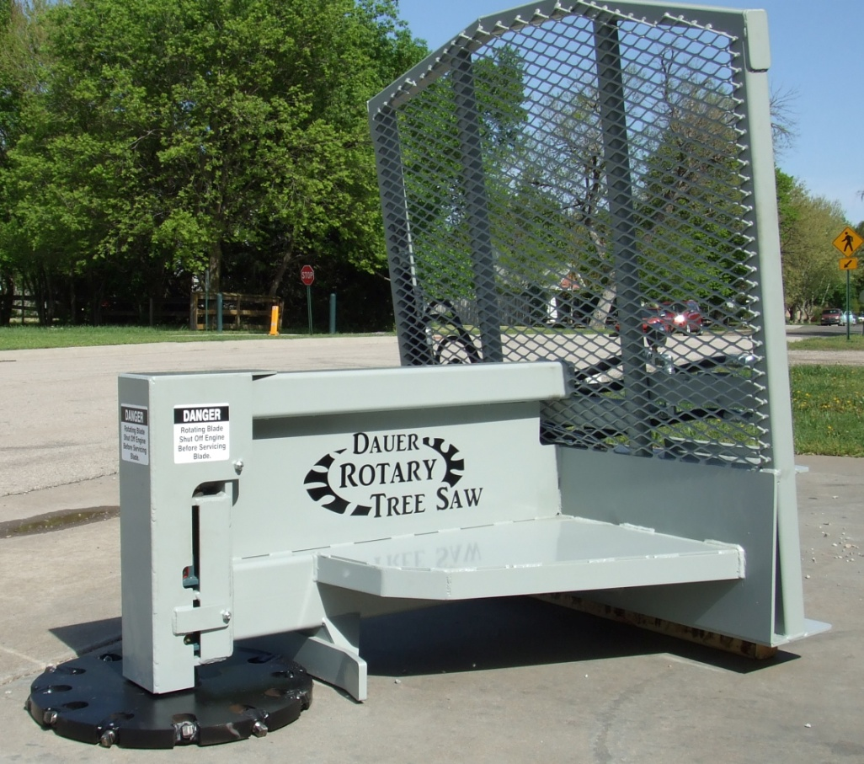

**Ideal Operating Ranges**

19 GPM = 1350 RPM

To

24 GPM = 1850 RPM

**Total Weight**

1220 Pounds

**Heavy Duty Construction**

**Quick Tach fits most skid steer loaders**

**Complete with all hoses & couplers**

**Optional 12 volt sprayer available**

**Tucks Between Skid Steer and Saw**

**Heavy Blade Available 2 sizes**

**1 ½ x 23” or 1 ½ x 26”**

**12 Replaceable Carbides**

**Cuts Flush with Ground**

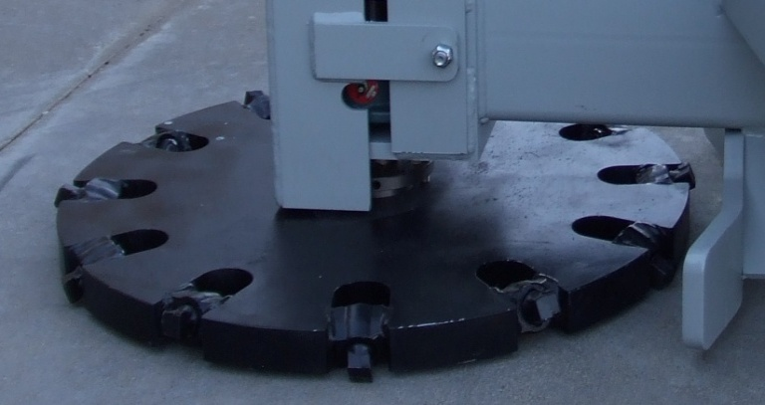 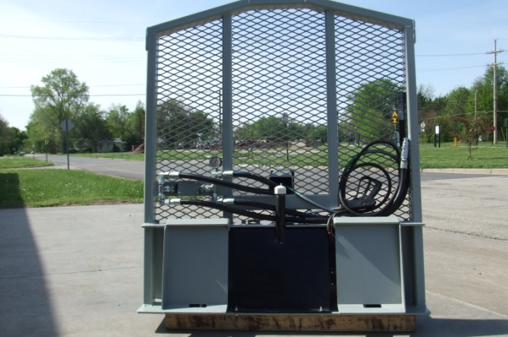

**Manufactured by:**

**Dauer Welding & Machine, Inc.**

301 East Union

Lindsborg, KS 67456

**(785) 227-3531**

[www.dauerwelding.com](http://www.dauerwelding.com)

[dauerwelding@sbcglobal.net](mailto:dauerwelding@sbcglobal.net)